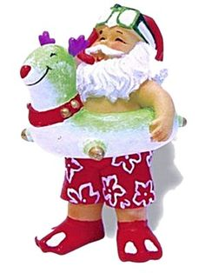
BGHS
Christmas Practice schedule

Friday, December 19th 3:15 to 4:30
Saturday, December 20th 8 to 10 am 4 to 6 pm
Sunday, December 21st 8 to 10 am Dirty Santa Party 6:30 PM
Monday, December 22nd 8 to 10 am 4 to 6 pm
Tuesday, December 23rd 8 to 10 am 4 to 6 pm
Wednesday, December 24th 8 to 11 am OFF
Thursday, Christmas Day OFF
Friday, December 26th 8 to 10 am 4 to 6 pm
Saturday, DEE”S BIRTHDAY*** 8 to 10 am 4 to 6 pm
Sunday, December 28th 8 to 10 am OFF
Monday, December 29th 8 to 10 am 4 to 6 pm
Tuesday, December 30th 8 to 10 am 4 to 6 pm
Wednesday, December 31st 8 to 11 am 12 ½ Championships
Thursday, NEW YEARS DAY OFF
Friday, January 2nd 8 to 10 am OFF
Saturday, January 3rd 8 to 10 am OFF
Sunday, January 4th OFF

